## **PROJECT REPORT TEMPLATE**

**TITLE: TRACING THE GROWTH OF GLOBAL COMMUNITY: A POPULATION FORECASTING ANALYSIS**

**1.INTRODUCTION**

**1.1 OVERVIEW**

The world’s population is more than three times larger than it was in the mid-twentieth century. The global human population reached 8.0 billion in mid-November 2022 from an estimated 2.5 billion people in 1950, adding 1 billion people since 2010 and 2 billion since 1998. The world’s population is expected to increase by nearly 2 billion persons in the next 30 years, from the current 8 billion to 9.7 billion in 2050 and could peak at nearly 10.4 billion in the mid-2080s.

This dramatic growth has been driven largely by increasing numbers of people surviving to reproductive age, the gradual increase in human lifespan, increase in urbanization, and accelerating migration. Major changes in fertility rate have accompanied this growth. These trends will have far-reaching implications for generations to come.

**1.2 PURPOSE**

Population forecasting is very important to know the growth rate and to estimate future population of particular area. Agricultural resources development, water demand and urban facilities are managed based on population projection. A population projection gives a picture of what the future size and structure of the population by sex and age might look like. It is based on knowledge of the past trends, and , for the future, on assumptions made of three components: fertility, mortality and migration. Understanding population growth is important for predicting, managing, monitoring, and eradicating pest and disease outbreaks.

**2.PROBLEM DEFINITION AND DESIGN THINKING**

**2.1 EMPATHY MAP**

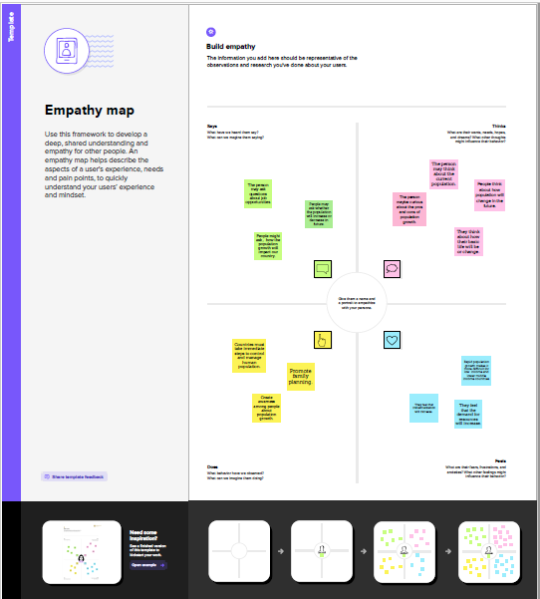

**2.2 IDEATION AND BRAINSTORMING MAP**

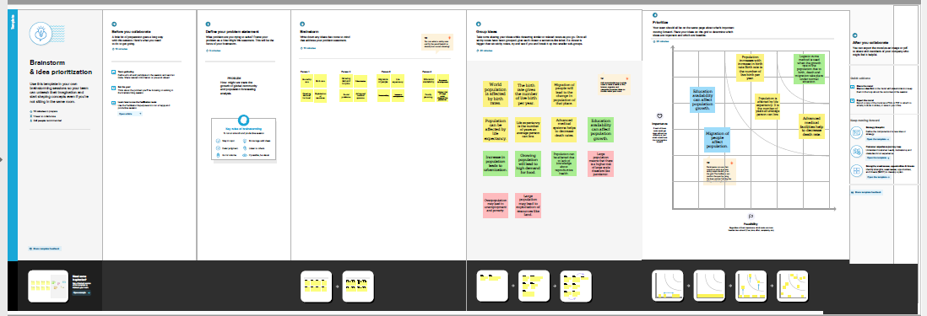

**3.RESULT**

We have used the dataset to create visualization. Then we have organized the data into dashboard and story which is data in an organized easy-to-read format.

**3.1. DASHBOARD**

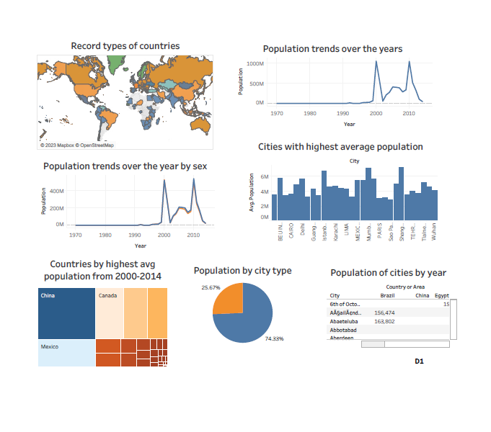

**3.2. STORY**

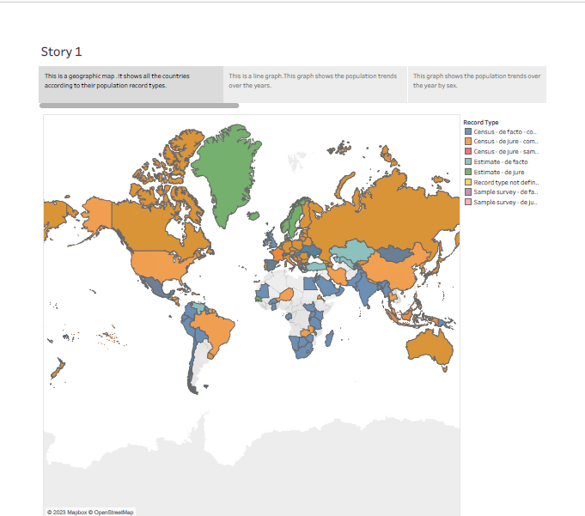

**4.ADVANTAGES AND DISADVANTAGES**

* Advanced medical facilities help to decrease death rates but it is not accessible to every people in the country and it is impossible to provide healthcare to everyone at the right time.
* Population varies due to migration of people. So, it causes increase in population density in one place and decrease in another place.
* It is difficult to control disasters, infections or pandemic if the population is high.
* Increase in population leads to increase in job opportunities but may also lead to unemployment.
* Population increase may lead to overexploitation of resources.

**5.APPLICATIONS**

Population projections can be used as a tool to provide information on possible scenarios of future population and, namely, to support decision-making processes in diverse socio-economic areas, such as, higher education institutional network planning, both in public and private sectors. Population density data can be used to quantify demographic information and to assess relationships with ecosystems, human health, and infrastructure.

**6.CONCLUSION**

Population growth has been driven largely by major changes in fertility rate, increasing urbanization and accelerating migration. These trends will have far-reaching implications for generations to come. They effect economic development, employment, income distribution, poverty and social protection.

**7.FUTURE SCOPE**

Population analysis is need to identify problems and community needs, establish goals and objectives, asses alternative courses of action, allocate resources for plan implementation, and evaluate the ability to achieve goals and objectives. In2011, the global population reached the 7billion mark, it stands at almost 7.9 billion in 2021, and it’s expected to grow to around 8.5 billion in 2030, 9.7 billion in 2050, and 10.9 billion in 2100.